**Q1) Write a function to Calculate the total stock value for a given category:**

**(Stock value=ROUND(SUM(unit_price * units_in_stock)::DECIMAL, 2)Return data type is DECIMAL(10,2)*/**

**Query:**

create or replace function calculate_category_stock(in categoryid int)

returns decimal(10,2)

language plpgsql

AS $$

declare

totalstock decimal(10,2);

Begin

if not exists ( select 1 from products where category_id=categoryid) then

raise exception 'Category id % does not exists',categoryid;

return 0;

end if;

**-- Calculate the total stock by catgeory**

select ROUND(SUM(unit_price * units_in_stock)::DECIMAL, 2) into totalstock

from products p where p.category_id = categoryid;

return totalstock;

End;

$$;

**Output:**

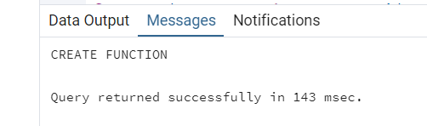

**Query:**

SELECT category_id, calculate_category_stock(category_id) AS TotalStockValue FROM (

SELECT DISTINCT category_id

FROM products

WHERE category_id IS NOT NULL

) AS categories;

**Output:**

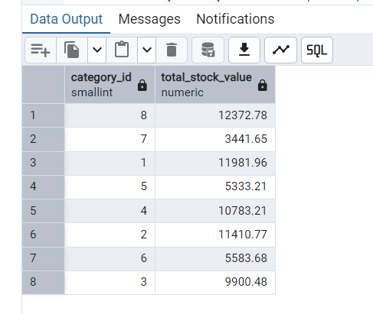

**Q2). Try writing a cursor query which I executed in the training.*/**

**Query:**

create or replace procedure update_prices_with_cursor()

language plpgsql

As $$

declare

product_cursor cursor for

select product_id,product_name, unit_price, units_in_stock

from products

where discontinued =0;

product_record Record;

v_new_price decimal(10,2);

Begin

**--open the cursor**

open product_cursor;

loop

**--Fetch the next row**

Fetch product_cursor into product_record;

exit when not found;

if product_record.units_in_stock <10 then

v_new_price := product_record.unit_price * 1.1;

else

v_new_price := product_record.unit_price * 0.95;

end if;

**update products**

set unit_price = round(v_new_price,2) where product_id = product_record.product_id;

raise notice 'update % price from % to %',

product_record.product_name,

product_record.unit_price,

v_new_price;

end loop;

close product_cursor;

end;

$$;

**Output:**

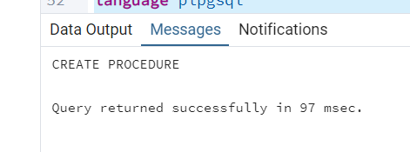

call update_prices_with_cursor();

**Output:**

